November 21, 2019

NOTIFICATION OF AUDIT RELEASE

Hickman County Official:

The Division of Local Government Audit will release the Annual Financial Report of Hickman County, Tennessee, for the year ended June 30, 2019, on November 25, 2019. A PDF file containing this report has been provided to the county mayor, road superintendent, director of schools, and the county’s finance director. Interested officials and citizens may obtain a copy of the PDF file from one of the officials noted above. Also, this report will be available for inspection at https://comptroller.tn.gov/office-functions/la.html.

Auditors are available to meet with the county’s Audit Committee to discuss all aspects of the audit upon the request of that committee. Requests should be made to the Middle Tennessee audit manager for available dates and times:

Middle Tennessee Audit Manager – Jeff Bailey 615-401-7841 or jeff.bailey@cot.tn.gov

Included with this notice is a copy of the Summary of Audit Findings.

Very truly yours,
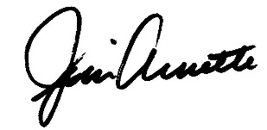
James R. Arnette, Director

Media Contact:
John Dunn, Public Information Officer, john.dunn@cot.tn.gov 615-401-7755

